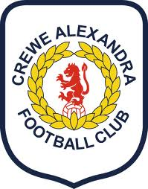

Brush Past Policy
To mitigate any risks inherent in the various configurations of seat allocations available supporters are asked to observe and practice the following control measures.

One of the issues is the ‘brush past’ other supporters

Unless an entire row of seats is occupied by supporters from the same social bubble, spectators wishing to access their seats or leave their seats during an event will need to pass in front of, or brush past other supporters from a different social bubble.

Crewe Alexandra FC has assessed the possible risks inherent in this action and has adopted control measures to minimise such risks.

These measures include:
- choosing to allocate seats in one row to the same social bubble, where it does not reduce capacity excessively wherever possible
- strongly recommending that supporters wear face coverings within the stadium.
- advising supporters on the move to turn their backs as they brush past other supporters to avoid face-to-face contact.
- avoiding physical contact with others outside their social bubble
- advising supporters to take up their seats as soon as they arrive and not to congregate on the pitchside track
- advising that supporters remain in their seats throughout the event wherever possible.

These control measures will be adopted for each game and be included in the Spectators’ Code of
Conduct.

Ticket holders will be directed to study the Supporters’ Code of Conduct prior to attending a match or purchasing tickets so that they decide whether or not they wish to proceed with the transaction.

